E- LEARNING MANAGEMENT SYSTEM

ABSTRACT
This project “E - Learning Management System” is a web based application which is useful for users. This system mainly deals to manage the online courses for users. This application has been designed and developed a comprehensive web-based system to better support the users benefit and requirement. By using this application will make the users less wasted time, and they will be able to easily get all the studies information. As a result, they will be able to continue their studies better. Using this platform users can view and read the material according to their needs. By using this application users will be able to check which new reading material is available for their studies. The project objective will be focused on developing an online course material to ensure the effectiveness of the flow of course materials. Moreover, the system will offer a complete management system that integrated with the online course material to help the users for maintaining the flow process of the course. By using this application users will be able to check which new reading material is available for their studies.

CONTENT
SNO | TITLE | PAGE NO
1 | INTRODUCTION
 | ORGANIZATION PROFILE
 | SYSTEM SPECIFICATION
 | HARDWARE CONFIGURATION
 | SOFTWARE SPECIFICATION
2 | SYSTEM STUDY
 | EXISTING SYSTEM
 | DRAWBACKS
 | PROPOSED SYSTEM
 | FEATURES
3 | SYSTEM DESIGN AND DEVELOPMENT
 | FILE DESIGN
 | INPUT DESIGN
 | OUTPUT DESIGN
 | DATABASE DESIGN
 | SYSTEM DEVELOPMENT
 | DESCRIPTION OF MODULES
4 | TESTING AND IMPLEMENTATION
5 | CONCLUSION BIBLIOGRAPHY
 | APPENDICES
 | A. DATA FLOW DIAGRAM
 | B. TABLE STRUCTURE
 | C. SAMPLE CODING
 | D. SAMPLE INPUT
 | E. SAMPLE OUTPUT

CHAPTER 1

- INTRODUCTION
INTRODUCTION:
ABOUT THE PROJECT:
The e-Learning management system allows both students and faculty members to manage different course activities throughout the semester. Faculty members will be able to offer courses, manage different activities of courses such as assignment uploading, Quiz management, and evaluation, Time table schedule, course material uploading, etc.
Moreover, the e-Learning management system will also provide the fee status of students, fine and attendance records. On the other hand, students would be able to upload assignments, attempt quizzes, attempt quizzes, check class timing and download different courses related material.
The e-Learning management system is implemented both in the distance learning system and also in the traditional teaching system to help faculty manage their course well and increase productivity. Moreover “e-Learning Management System” would be able to reduce the burden of faculty staff.
Instructors who wish to use courseware have problems deciding between an out of the box solution versus a customized system. Additionally, computer literacy among educators does not typically include programming experience. For these reasons, a piece of software that is both customizable and easy to install is required to fit their needs. Today, the software is still cumbersome and difficult to configure. For educators all over the world, providing the best of flexibility and ease of use has been a consistent problem since the advent of e-Learning management systems.

ABOUT THE ORGANIZATION:
Rapid Software House inaugurate as a student project center with lot of B.Tech, M.Tech, MBA, Polytechnic and Arts and Science students were migrated here for doing her/his final year project and mini project. Now, we are a leading expert in project development and IT solution in Tindivanam. We are also develop business process application, web Development, SEO, PHD project assistance, Andriod Applications, Cloud Servers, Technical Journals, Mechanical Resource Deputation and Placement, Image Processing, Wireless Communication. We pioneer in CSE, IT, ECE, MECHANICAL.
AIM:
- To provide quality education of information technology and IT enabled services to shine as leading business promoters on real time and submission of application and system software.
- To develop the efficient candidates as per the requirement of major IT sectors.
- To serve the society by releasing free wares.
- To provide a wide range of ideas and thoroughly to the environment about the development of information technology and its enabled fields.
MOTTO:
Our motto explains that even a middle class student can learn the booming technology which is highly costlier for them.

SYSTEM SPECIFICATIONS:
HARDWARE CONFIGURATIONS:-
The hardware used for the development of the project is:
    - PROCESSOR : PENTIUM - I3
    - RAM : 2 GB
    - HARD DISK : 500 GB
    - MOTHER BOARD : INTEL
    - KEY BOARD : LOGITECH B490
    - MOUSE : LOGITECH ( 3 Buttons)

SOFTWARE CONFIGURATIONS: -
The software used for the development of the project is:
  - OPERATING SYSTEM : Windows 8.1
  - FRONTEND : PHP v5.2
  - BACKEND : MYSQL Server 5.0
  - BROWSER : Internet Explorer

CHAPTER 2
SYSTEM STUDY
      - EXISTING SYSTEM
      - PROPOSED SYSTEM

EXISTING SYSTEM:
E- Learning management systems (for example, Canvas, Blackboard, etc.) are web‐based software systems that support teaching and learning in face‐to‐face as well as online environments. Faculty members directly manage their course content in course management systems. These guidelines relate only to copyright issues.
Materials posted must be in the legal possession of the Library, faculty member, or the institution; or legally obtained, and must be used solely for non-profit, educational purposes. It is preferable to link to materials already legally available rather than photocopying or scanning and posting a digital copy.
All scans or reproductions posted should represent a small portion of the whole copyrighted work. Library staff (see below) can offer guidance about the appropriate proportion to use. Complete works (such as a whole book, whole album of music, or whole journal issue) should not be posted without permission.
Drawbacks of Existing System
- User friendliness is provided in the application with various controls.
- The system makes the overall project management much easier and flexible.
- Readily upload the latest updates, allows user to download the alerts by clicking the URL.
- There is no risk of data mismanagement at any level while the project development is under process.
- It provides high level of security with different level of authentication.
PROPOSED SYSTEM
The purpose of project is to build an application program to reduce manual work for managing the course through internet. This application has good appearance and easy to operate. It is very simple and easy to access. This project provides lots of features to manage in very well manner. This project contains advance modules which make the backend system very powerful.
1. Online Course Material Management System project is developed as a web application and it will work over web.
2. Using this project user can see and save their class materials.
3. This project will only applicable for educational institutions.
The advantages of the proposed system
- User Friendly: User interface is very easy. Data storing and recovery is fast and secured. In addition, application is provided with graphical representation for easier interpretation and analysis.
- It is smart learning application
- Avoiding paper use
- Time consuming

CHAPTER 3
SYSTEM DESIGN AND DEVELOPMENT
      - FILE DESIGN
      - INPUT DESIGN
      - OUTPUT DESIGN
      - DATABASE DESIGN
      - SYSTEM DEVELOPMENT

FILE DESIGN:
1.Master file :
A master file is collection of records about an important aspect of an organizations activities. It may contain the data describes the current status of specific events or business indicators. For example, the master file in accounts payable system shows the balance owed to every vendor or suppliers. A second type of master file reflects the history of events affecting a particular entity. Suppose in any organization any employee leaves the organization at that time all the details of the employee must be stored. In computer such type of data or information are stored as history file. Master file are useful only so long as they are kept accurate and up to date.
2. Transaction file :
A transaction file is a temporary file with two purpose accumulating the data about events as they occurs and updating master files to reflect the results of current transactions. The term transactions refers to any business event that affects the organization and about which data are captured. Each transaction file contains only the records that pertain to the particular entities that are subject to the file. The details are accumulated as a record at a time in transaction file. The transaction and master file are read at the same time by a program and master file is revised depending upon the transactions.
Master files are permanent and exist as long as the system exists. However, the contents of the files change as a result of processing and updating. Transaction files, on the other hand, are temporary. At some time they are no longer needed and are erased or destroyed, depending upon the method used for time durations.

3. Table file :
A special type of master file is included in many systems to meet special processing requirements involving data that must be referenced repeatedly. Table files contain reference data used in processing transactions, updating master files, or producing output. Analyst often specify the use of table files to store data that otherwise would be included in master files or embedded in computer program. Table file conserve storage space and ease program maintenance by storing in a file data that otherwise would be included in programs or master file.
4. Report file :
The central processing unit of computer very often produces data for output at a faster rate than the printer can possibly keep up with. Following the normal sequence of events, processing would have to be delayed while the result are printed. To prevent such inefficient use of the cpu, the analyst generates the output in a text file called the report file. Report files are temporary files used when printing time is not available for all the reports produced, a situation that frequently arises in overlapped processing. The computer writes the output to a file on
secondary storage. This file will be used whenever it is required and will be deleted when the use of the file is over.
5.Other files :
Other kind of files, as well as special uses of the file types previously discussed, play a role in information system. For example a backup file is a copy of master file , transaction file or table file made to ensure that duplicate is available if anything happens to the original file.

Methods of file organization
Records are stored in files using a file organization that determines how the records will be stored, located and retrieved. There are basically three methods to store the records are as follow :
- Sequential organizations : It is the simplest way to store and retrieve records in a file. In a sequential file records are stored one after the other without concern for the actual value of the data in the records. The first record is stored at the beginning of the file. The second record is stored right after the first record and so on. This order never change in sequential file organization. A characteristic of sequential file is that all records are stored by position: first record, second record and so on. There are no addresses or location assignments in sequential file.
- Direct access organization : This method requires the program to tell the system where a record is stored before it can access the record. In contrast to sequential organization, processing a direct access file does not require the system to start at the first record in the file. Using the record key as the storage address is called direct addressing.
- Indexed organization : A third way of accessing records is through an index. The basic form of index includes a record key and the storage address for a record. To find a record when the storage address is unknown it is necessary to scan the records. However the search will be faster if an index is used, since it takes less time to search an index than an
entire file.

INPUT DESIGN:

File Name: index.php

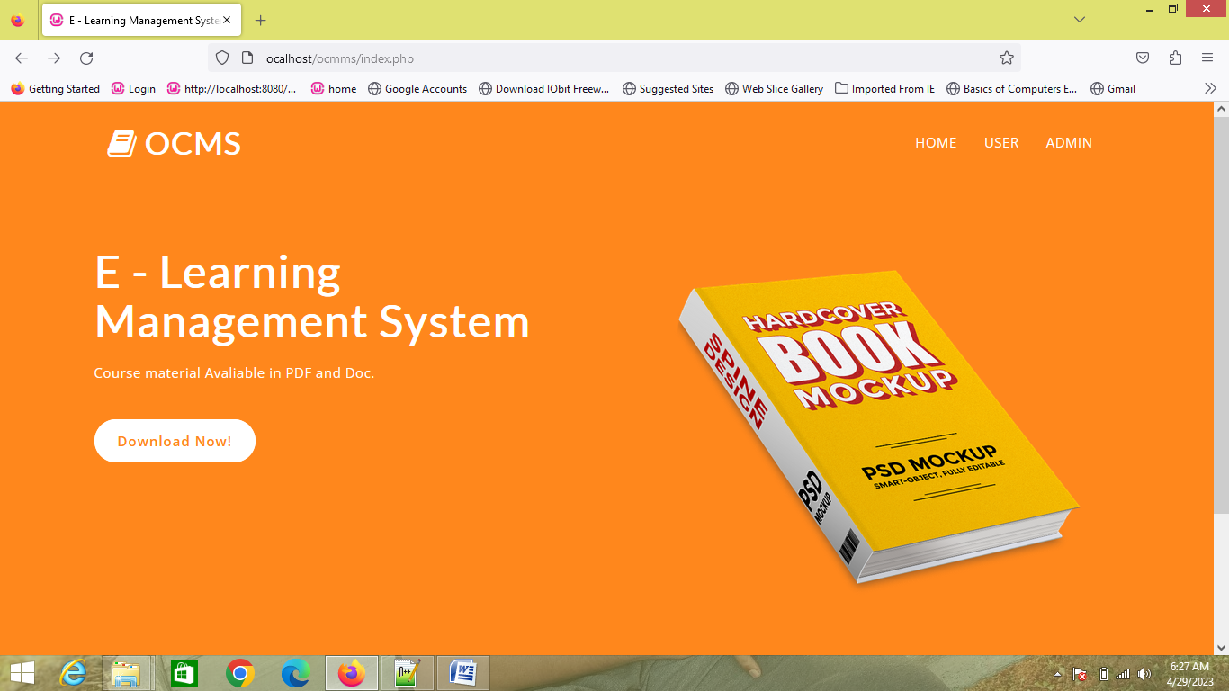

Description:
This page is used to show the home page of the system.

File Name: Signin.php

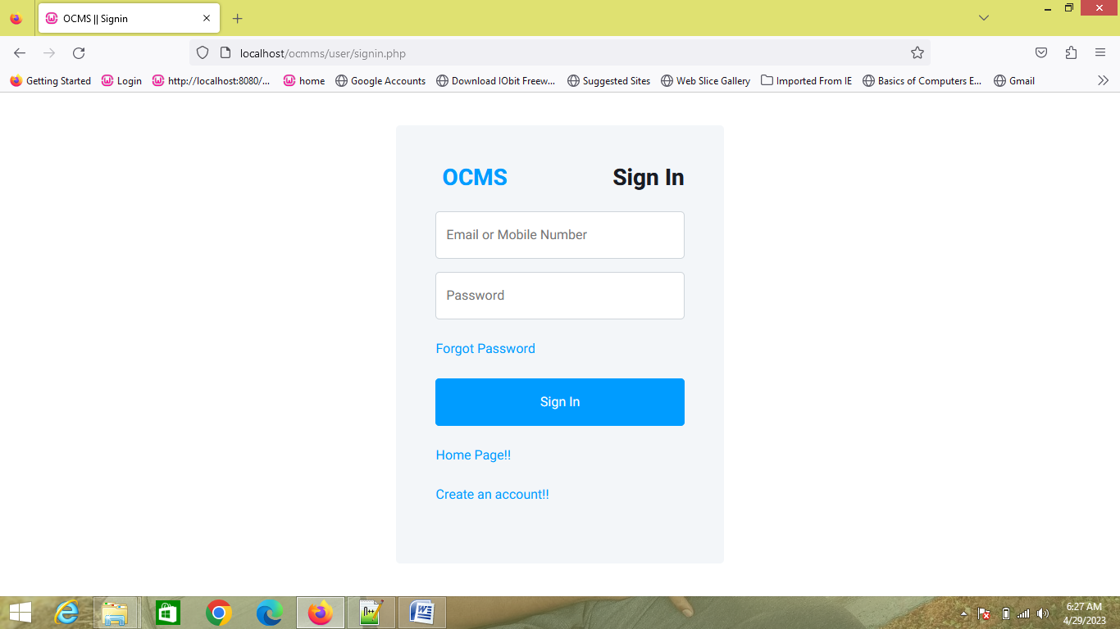

Description:
This page is used to signin purpose to students of the institution.

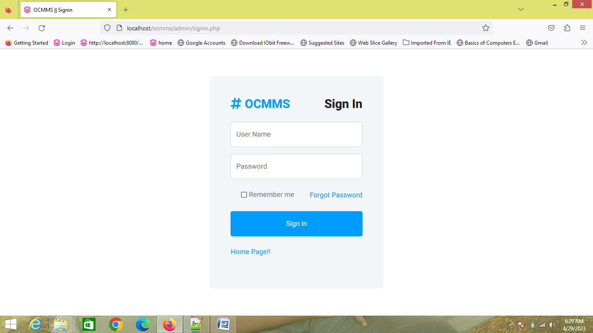

Description:
This page is used to signin purpose to the admin of the institution.

OUTPUT DESIGN:

File Name: dashboard.php

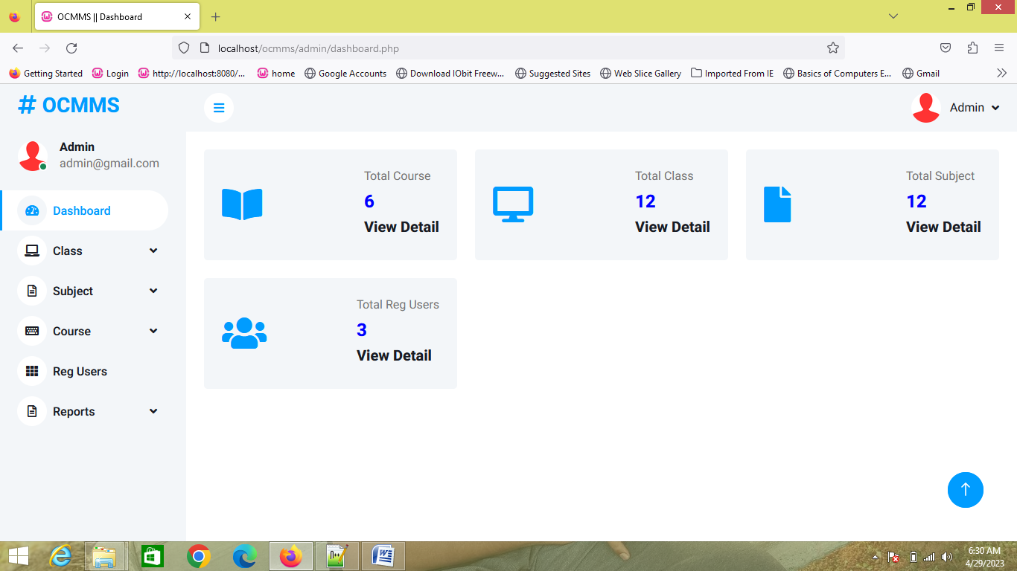

Description:
This page is used as a dashboard that displays overall details about the system to admin user.

File Name: manage_course.php

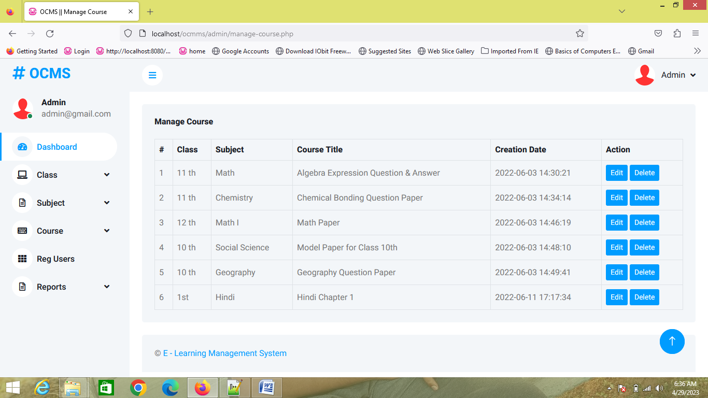

Description:
This page is showed to show the available courses in the system
SYSTEM DEVELOPMENT
DESCRIPTION OF MODULES
BASIC MODELS
The application named “E - Learning Management System” which is a web-based application. This application will be most convenient for user’s study purpose and they will be benefited most. Because this application has beneficial and helpful feature are exist which will be use the user. In this application there have two panel i.e., Admin and User panel.
Admin Panel:
- Dashboard: In this section, admin can view all the detail in brief like Total Courses, Total Classes, Total Subject and Total Registered Users.
- Class: In this section, admin can manage the class(Add/Delete/Update).
- Subject: In this section, admin can manage the subject(Add/Delete/Update).
- Course: In this section, admin can manage the course(Add/Delete/Update).
- Reg Users: In this section, admin can view the registered users’ details.
- Reports: In this section,admin can view the details of course uploaded in particular period according to class.
Admin can also update his profile, change the password and recover the password.
User Panel
- User(User) can log in with registered mobile number or email and password. User can view and download any course according to their class course.
- User can also update his profile, change the password and recover the password.

CHAPTER 4
TESTING AND IMPLEMENTATION

TESTING
The purpose of testing is to discover errors. Testing is the process of trying to discover every conceivable fault or weakness in a work product. It provides a way to check the functionality of components, sub-assemblies, assemblies and/or a finished product. It is also the process of exercising software with the intent of ensuring that the it meets its requirements, user expectations and does not fail in an unacceptable manner. There are various types of test that can be performed. Each type of test addresses a specific testing requirement.
Types of Tests
Unit testing.
Unit testing involves the design of test cases that validate that the internal program logic is functioning properly, and that the program inputs produce valid outputs. All decision branches and internal code flow should be validated by this test. It is the testing of individual software units of the application. It is done after the completion of an individual unit but before integration. This is a structural test, that relies on knowledge of its construction and it is invasive. Unit tests perform basic tests at the component level and test a specific business process, application, and/or system configuration. Unit tests also ensure that each unique path of a business process performs accurately to the documented specifications and contains clearly defined inputs and expected results.
Unit testing is usually conducted as part of a combined code and unit test phase of the software lifecycle, although it is not uncommon for coding and unit testing to be conducted in two distinct phases. Test strategy and approach. Field testing will be performed manually, and functional tests will be written in detail.

Test objectives
- All field entries must work properly.
- Pages must be activated from the identified link.
- The entry screen, messages and responses must not be delayed.
- Features to be tested
- Verify that the entries are of the correct formats
- No duplicate entries should be allowed.
- All links should take the user to the correct page.

Integration testing.
Integration tests are designed to test integrated software components to determine if they run as one cohesive program. Testing is event driven and is more concerned with the basic outcome of screens or fields. Integration tests demonstrate that although the components were individually satisfactory, as shown by successful unit testing, the combination of components is performing correctly and consistently. Integration testing is specifically aimed at exposing the problems that arise from the combination of these components. Software integration testing is the incremental integration testing of two or more integrated software components on a single platform to produce failures caused by interface defects.
The task of the integration test is to check that components or software applications, e.g. components in a software system or – one step up – software applications at the company level interact without error. All the test cases mentioned above passed successfully, and no defects were encountered.
Acceptance testing.
User acceptance testing is a critical phase of any project and requires significant participation by the end user. It also ensures that the system meets the functional requirements. All the test cases mentioned above passed successfully, and no defects were encountered.
Functional testing.
Functional tests provide systematic demonstrations that functions tested are available as specified by the business and technical requirements, system documentation, and user manuals. Functional testing is centered on the following items:
- Valid Input: identified classes of valid inputs must be accepted.
- Invalid Input: identified classes of invalid inputs must be rejected.
- Functions: identified functions must be exercised.
- Output: identified classes of application outputs must be exercised.
- Systems/Procedures: interfacing systems or procedures must be invoked.
The organization and preparation of functional tests is focused on requirements, key functions, or special test cases. In addition, the systematic coverage pertaining to identifying business process flows; data fields, predefined processes, and successive processes must be considered for testing. Before functional testing is complete, additional tests are identified and the effective value of current tests is determined.

System testing.
System testing ensures that the entire integrated software system meets requirements. It tests a configuration to ensure known and predictable results. An example of system testing is the configuration-oriented system integration test. System testing is based on process descriptions and flows, emphasizing pre-driven process links and integration points. There will be different layers to test and this system testing comes under a higher environment and will have restricted access to normal testers.
White box testing.
White box testing is a test in which the software tester has knowledge of the inner workings, structure and language of the software, or at least its purpose. Its purpose is used to test areas that cannot be reached from a black box level.
Black box testing.
Black box testing is a test of the software without any knowledge of the inner workings, structure or language of the module being tested. Black box tests, as with most other kinds of tests, must be written from a definitive source document, such as a specification or requirements document. It is a test in which the software under test is treated, as a black box. You cannot “see” into it. The test provides inputs and responds to outputs without considering how the software works.

CHAPTER 5
CONCLUSION AND BIBLIOGRAPHY

CONCLUSION:
Although our ambition was to achieve a complete system that will have a highly accuracy. We have managed to develop a system and a guideline to on how an application can be developed for e-learning management system based on web. We have face with many errors and fixed it. I designed this application interface is simply and well organized so that the user can easily cooperate with it. We tried to improve its accuracy and keep it acceptable by user. I tried my best for best result and keep user friendly. And I hope the user will be benefitted.

REFERENCES:
- WHATWG (Web HyperText Application Working Group) HTML Specfication @ https://html.spec.whatwg.org/multipage/.
- CSS 2.1 Specification W3C Recommendation Revised 17 December 2014 (@ https://www.w3.org/TR/CSS21/).
- W3C CSS Specification @ https://www.w3.org/Style/CSS/specs.en.html.
- W3School's JavaScript Tutorials, References and Examples @ https://www.w3schools.com/.
- PHP mother site @ http://php.net/.
- PHP Manual @ http://php.net/manual/en/.
- PHP Language Reference @ http://php.net/manual/en/langref.php.
- MySQL Mother Site @ www.mysql.com.
- MySQL 5.7 "Reference Manual" @ http://dev.mysql.com/doc/.
- MySQL 5.7 "SQL Statement Syntax" @ http://dev.mysql.com/doc/refman/5.7/en/sql-syntax.html.

APPENDICES
- DATA FLOW DIAGRAM:

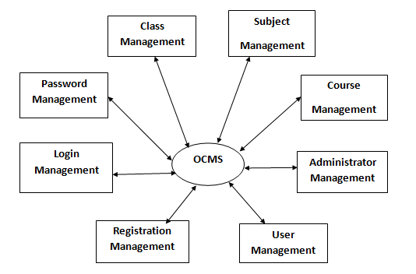

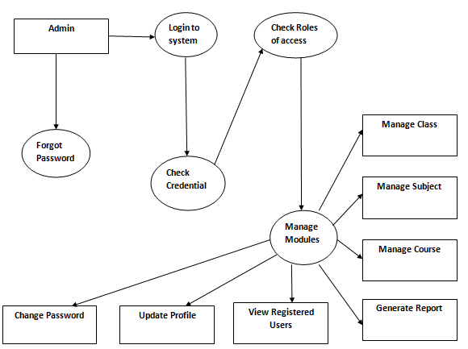

ER DIAGRAM

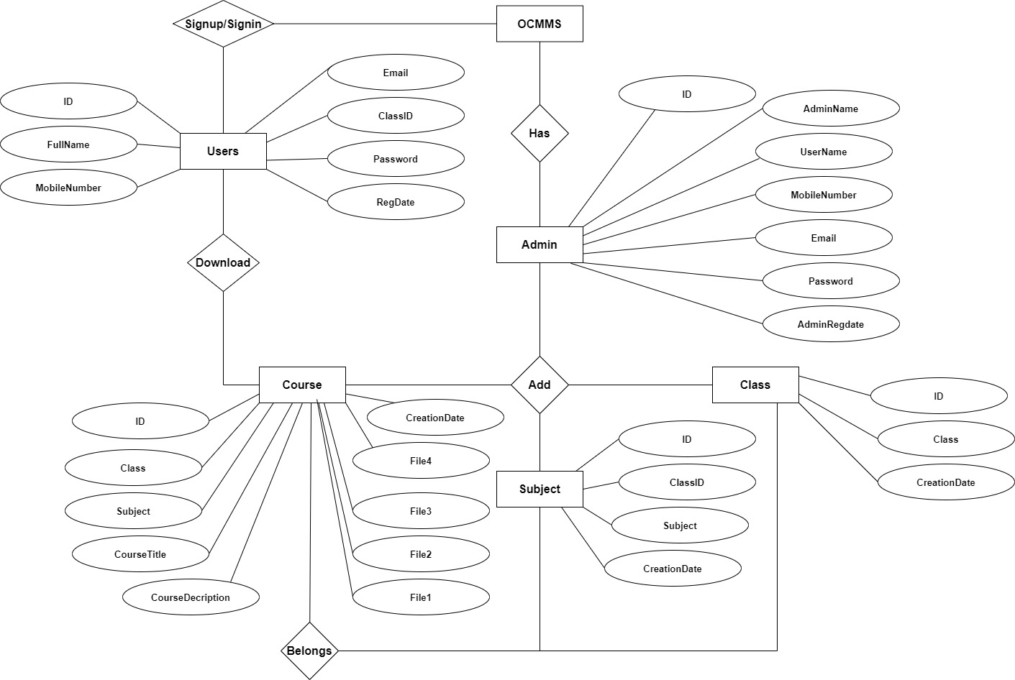

USE CASE DIAGRAM:

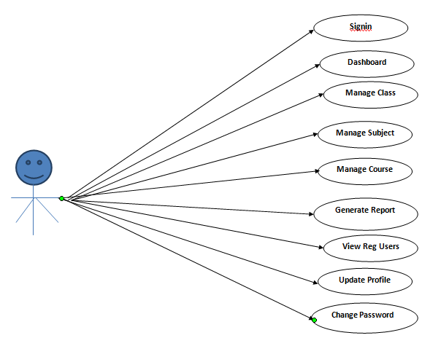
- TABLE STRUCTURE:

Table Name: users
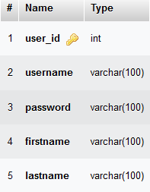

Table Name: admin
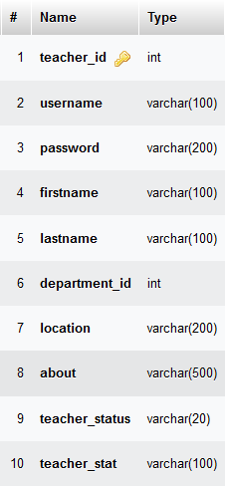

Table Name: subject

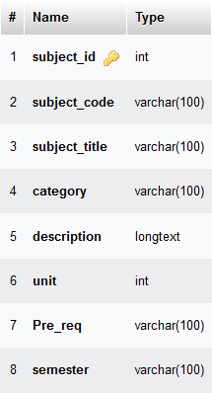

- SAMPLE CODING:
FileName: index.php:
<?php
session_start();
//error_reporting(0);
include('includes/dbconnection.php');

if(isset($_POST['login']))
{
$emailormobnum=$_POST['emailormobnum'];
$password=md5($_POST['password']);
$sql ="SELECT Email,MobileNumber,Password,ID,ClassID FROM tbluser WHERE (Email=:emailormobnum || MobileNumber=:emailormobnum) and Password=:password";
$query=$dbh->prepare($sql);
$query->bindParam(':emailormobnum',$emailormobnum,PDO::PARAM_STR);
$query-> bindParam(':password', $password, PDO::PARAM_STR);
$query-> execute();
$results=$query->fetchAll(PDO::FETCH_OBJ);
if($query->rowCount() > 0)
{
foreach ($results as $result) {
$_SESSION['ocasuid']=$result->ID;
$_SESSION['ocasucid']=$result->ClassID;
}
$_SESSION['login']=$_POST['emailormobnum'];

echo "<script type='text/javascript'> document.location ='dashboard.php'; </script>";
} else{
echo "<script>alert('Invalid Details');</script>";
}
}
?>
<!DOCTYPE html>
<html lang="en">
<head>
<title>OCMS || Signin</title>
<!-- Google Web Fonts -->
<link rel="preconnect" href="https://fonts.googleapis.com">
<link rel="preconnect" href="https://fonts.gstatic.com" crossorigin>
<link href="https://fonts.googleapis.com/css2?family=Heebo:wght@400;500;600;700&display=swap" rel="stylesheet">

<!-- Icon Font Stylesheet -->
<link href="https://cdnjs.cloudflare.com/ajax/libs/font-awesome/5.10.0/../admin/css/all.min.css" rel="stylesheet">
<link href="https://cdn.jsdelivr.net/npm/bootstrap-icons@1.4.1/font/bootstrap-icons.css" rel="stylesheet">

<!-- Libraries Stylesheet -->
<link href="../admin/lib/owlcarousel/assets/owl.carousel.min.css" rel="stylesheet">
<link href="../admin/lib/tempusdominus/../admin/css/tempusdominus-bootstrap-4.min.css" rel="stylesheet" />

<!-- Customized Bootstrap Stylesheet -->
<link href="../admin/css/bootstrap.min.css" rel="stylesheet">

<!-- Template Stylesheet -->
<link href="../admin/css/style.css" rel="stylesheet">
</head>

<body>
<div class="container-fluid position-relative bg-white d-flex p-0">
<!-- Spinner Start -->
<div id="spinner" class="show bg-white position-fixed translate-middle w-100 vh-100 top-50 start-50 d-flex align-items-center justify-content-center">
<div class="spinner-border text-primary" style="width: 3rem; height: 3rem;" role="status">
<span class="sr-only">Loading...</span>
</div>
</div>

<!-- Sign In Start -->
<div class="container-fluid">
<div class="row h-100 align-items-center justify-content-center" style="min-height: 100vh;">
<div class="col-12 col-sm-8 col-md-6 col-lg-5 col-xl-4">
<div class="bg-light rounded p-4 p-sm-5 my-4 mx-3">
<div class="d-flex align-items-center justify-content-between mb-3">
<a href="index.html" class="">
<h3 class="text-primary"><i class="fa fa-hashtag me-2"></i>OCMS</h3>
</a>
<h3>Sign In</h3>
</div>
<form method="post">
<div class="form-floating mb-3">
<input type="text" class="form-control" placeholder="Email or Mobile Number" required="true" name="emailormobnum">
<label for="floatingInput">Email or Mobile Number</label>
</div>
<div class="form-floating mb-4">
<input type="password" class="form-control" placeholder="Password" name="password" required="true">
<label for="floatingPassword">Password</label>
</div>
<div class="d-flex align-items-center justify-content-between mb-4">
<a href="forgot-password.php">Forgot Password</a>
</div>
<button type="submit" class="btn btn-primary py-3 w-100 mb-4" name="login">Sign In</button>
</form>
<div class="d-flex align-items-center justify-content-between mb-4">
<a href="../index.php">Home Page!!</a>
</div>
<div class="d-flex align-items-center justify-content-between mb-4">
<a href="signup.php">Create an account!!</a>
</div>
</div>
</div>
</div>
</div>
</div>
<script src="https://code.jquery.com/jquery-3.4.1.min.js"></script>
<script src="https://cdn.jsdelivr.net/npm/bootstrap@5.0.0/dist/js/bootstrap.bundle.min.js"></script>
<script src="../admin/lib/chart/chart.min.js"></script>
<script src="../admin/lib/easing/easing.min.js"></script>
<script src="../admin/lib/waypoints/waypoints.min.js"></script>
<script src="../admin/lib/owlcarousel/owl.carousel.min.js"></script>
<script src="../admin/lib/tempusdominus/js/moment.min.js"></script>
<script src="../admin/lib/tempusdominus/js/moment-timezone.min.js"></script>
<script src="../admin/lib/tempusdominus/js/tempusdominus-bootstrap-4.min.js"></script>

<!-- Template Javascript -->
<script src="../admin/js/main.js"></script>
</body>

</html>

FileName: login.php
<?php
session_start();
error_reporting(0);
include('includes/dbconnection.php');
if(isset($_POST['submit']))
{
$fname=$_POST['fname'];
$mobno=$_POST['mobno'];
$email=$_POST['email'];
$cid=$_POST['cid'];
$password=md5($_POST['password']);
$ret="select Email,MobileNumber from tbluser where Email=:email || MobileNumber=:mobno";
$query= $dbh -> prepare($ret);
$query-> bindParam(':email', $email, PDO::PARAM_STR);
$query->bindParam(':mobno',$mobno,PDO::PARAM_INT);

$query-> execute();
$results = $query -> fetchAll(PDO::FETCH_OBJ);
if($query -> rowCount() == 0)
{
$sql="insert into tbluser(FullName,MobileNumber,Email,ClassID,Password)Values(:fname,:mobno,:email,:cid,:password)";
$query = $dbh->prepare($sql);
$query->bindParam(':fname',$fname,PDO::PARAM_STR);
$query->bindParam(':email',$email,PDO::PARAM_STR);
$query->bindParam(':mobno',$mobno,PDO::PARAM_INT);
$query->bindParam(':cid',$cid,PDO::PARAM_INT);
$query->bindParam(':password',$password,PDO::PARAM_STR);
$query->execute();
$lastInsertId = $dbh->lastInsertId();
if($lastInsertId)
{

echo "<script>alert('You have successfully registered with us');</script>";
echo "<script>window.location.href ='signin.php'</script>";
}
else
{

echo "<script>alert('Something went wrong.Please try again');</script>";
}
}
else
{

echo "<script>alert('Email-id or Mobile Number is already exist. Please try again');</script>";
}
}
?>
<!DOCTYPE html>
<html lang="en">

<head>

<title>OCMS || Signup</title>

<!-- Google Web Fonts -->
<link rel="preconnect" href="https://fonts.googleapis.com">
<link rel="preconnect" href="https://fonts.gstatic.com" crossorigin>
<link href="https://fonts.googleapis.com/css2?family=Heebo:wght@400;500;600;700&display=swap" rel="stylesheet">

<!-- Icon Font Stylesheet -->
<link href="https://cdnjs.cloudflare.com/ajax/libs/font-awesome/5.10.0/../admin/css/all.min.css" rel="stylesheet">
<link href="https://cdn.jsdelivr.net/npm/bootstrap-icons@1.4.1/font/bootstrap-icons.css" rel="stylesheet">

<!-- Libraries Stylesheet -->
<link href="../admin/lib/owlcarousel/assets/owl.carousel.min.css" rel="stylesheet">
<link href="../admin/lib/tempusdominus/../admin/css/tempusdominus-bootstrap-4.min.css" rel="stylesheet" />

<!-- Customized Bootstrap Stylesheet -->
<link href="../admin/css/bootstrap.min.css" rel="stylesheet">

<!-- Template Stylesheet -->
<link href="../admin/css/style.css" rel="stylesheet">
</head>

<body>
<div class="container-fluid position-relative bg-white d-flex p-0">
<!-- Spinner Start -->
<div id="spinner" class="show bg-white position-fixed translate-middle w-100 vh-100 top-50 start-50 d-flex align-items-center justify-content-center">
<div class="spinner-border text-primary" style="width: 3rem; height: 3rem;" role="status">
<span class="sr-only">Loading...</span>
</div>
</div>
<!-- Spinner End -->

<!-- Sign In Start -->
<div class="container-fluid">
<div class="row h-100 align-items-center justify-content-center" style="min-height: 100vh;">
<div class="col-12 col-sm-8 col-md-6 col-lg-5 col-xl-4">
<div class="bg-light rounded p-4 p-sm-5 my-4 mx-3">
<div class="d-flex align-items-center justify-content-between mb-3">
<a href="index.html" class="">
<h3 class="text-primary"><i class="fa fa-hashtag me-2"></i>OCMS</h3>
</a>
<h3>Sign Up</h3>
</div>
<form method="post">
<div class="form-floating mb-3">
<input type="text" value="" name="fname" required="true" class="form-control">
<label for="floatingInput">Name</label>
</div>
<div class="form-floating mb-4">
<input type="text" name="mobno" class="form-control" required="true" maxlength="10" pattern="[0-9]+">
<label for="floatingPassword">Mobile Number</label>
</div>
<div class="form-floating mb-4">
<input type="email" class="form-control" value="" name="email" required="true">
<label for="floatingPassword">Email address</label>
</div>
<div class="form-floating mb-4">
<select type="text" value="" name="cid" required="true" class="form-control">
<option value="">Select Class</option>
<?php

$sql="SELECT * from tblclass";

$query = $dbh -> prepare($sql);
$query->execute();
$results=$query->fetchAll(PDO::FETCH_OBJ);
$cnt=1;
if($query->rowCount() > 0)
{
foreach($results as $row)
{

?>
<option value="<?php echo $row->ID;?>"><?php echo htmlentities($row->Class);?></option><?php $cnt=$cnt+1;}} ?>
</select>

</div>
<div class="form-floating mb-4">
<input type="password" value="" class="form-control" name="password" required="true">
<label for="floatingPassword">Password</label>
</div>
<div class="d-flex align-items-center justify-content-between mb-4">

<a href="signin.php">Already Registered !!</a>
</div>

<button type="submit" class="btn btn-primary py-3 w-100 mb-4" name="submit">Sign Up</button>

</form>
</div>
</div>
</div>
</div>
<!-- Sign In End -->
</div>

<!-- JavaScript Libraries -->
<script src="https://code.jquery.com/jquery-3.4.1.min.js"></script>
<script src="https://cdn.jsdelivr.net/npm/bootstrap@5.0.0/dist/js/bootstrap.bundle.min.js"></script>
<script src="../admin/lib/chart/chart.min.js"></script>
<script src="../admin/lib/easing/easing.min.js"></script>
<script src="../admin/lib/waypoints/waypoints.min.js"></script>
<script src="../admin/lib/owlcarousel/owl.carousel.min.js"></script>
<script src="../admin/lib/tempusdominus/js/moment.min.js"></script>
<script src="../admin/lib/tempusdominus/js/moment-timezone.min.js"></script>
<script src="../admin/lib/tempusdominus/js/tempusdominus-bootstrap-4.min.js"></script>

<!-- Template Javascript -->
<script src="../admin/js/main.js"></script>
</body>

</html>

File Name: viewcourse.php
<?php
session_start();
error_reporting(0);
include('includes/dbconnection.php');
if (strlen($_SESSION['ocasuid']==0)) {
header('location:logout.php');
} else{

?>
<!DOCTYPE html>
<html lang="en">
<head>
<title>OCMS || View Uploaded Courses</title>
<link rel="preconnect" href="https://fonts.googleapis.com">
<link rel="preconnect" href="https://fonts.gstatic.com" crossorigin>
<link href="https://fonts.googleapis.com/css2?family=Heebo:wght@400;500;600;700&display=swap" rel="stylesheet">

<!-- Icon Font Stylesheet -->
<link href="https://cdnjs.cloudflare.com/ajax/libs/font-awesome/5.10.0/css/all.min.css" rel="stylesheet">
<link href="https://cdn.jsdelivr.net/npm/bootstrap-icons@1.4.1/font/bootstrap-icons.css" rel="stylesheet">

<!-- Libraries Stylesheet -->
<link href="../admin/lib/owlcarousel/assets/owl.carousel.min.css" rel="stylesheet">
<link href="../admin/lib/tempusdominus/css/tempusdominus-bootstrap-4.min.css" rel="stylesheet" />

<!-- Customized Bootstrap Stylesheet -->
<link href="../admin/css/bootstrap.min.css" rel="stylesheet">

<!-- Template Stylesheet -->
<link href="../admin/css/style.css" rel="stylesheet">
</head>

<body>
<div class="container-fluid position-relative bg-white d-flex p-0">

<?php include_once('includes/sidebar.php');?>
<!-- Content Start -->
<div class="content">
<?php include_once('includes/header.php');?>

<div class="container-fluid pt-4 px-4">
<div class="bg-light text-center rounded p-4">
<div class="d-flex align-items-center justify-content-between mb-4">
<h6 class="mb-0">View Uploaded Courses</h6>

</div>
<div class="table-responsive">
<table class="table text-start align-middle table-bordered table-hover mb-0">
<thead>
<tr class="text-dark">
<th scope="col">#</th>
<th scope="col">Class</th>
<th scope="col">Subject</th>
<th scope="col">Course Title</th>
<th scope="col">Creation Date</th>
<th scope="col">Action</th>
</tr>
</thead>
<tbody>
<tr>
<?php
$stdcid=$_SESSION['ocasucid'];
$sql="SELECT tblclass.ID as cid,tblclass.Class,tblsubject.ID as sid,tblsubject.Subject,tblsubject.CreationDate,tblcourse.ID as courseid,tblcourse.CourseTitle,tblcourse.CreationDate as coursecd from tblcourse join tblclass on tblclass.ID=tblcourse.Class join tblsubject on tblsubject.ID=tblcourse.Subject join tbluser on tbluser.ClassID=tblclass.ID where tblclass.ID=:stdcid";
$query = $dbh -> prepare($sql);
$query-> bindParam(':stdcid', $stdcid, PDO::PARAM_STR);
$query->execute();
$results=$query->fetchAll(PDO::FETCH_OBJ);

$cnt=1;
if($query->rowCount() > 0)
{
foreach($results as $row)
{ ?>
<td><?php echo htmlentities($cnt);?></td>
<td><?php echo htmlentities($row->Class);?></td>
<td><?php echo htmlentities($row->Subject);?></td>
<td><?php echo htmlentities($row->CourseTitle);?></td>
<td><?php echo htmlentities($row->coursecd);?></td>

<td><a class="btn btn-sm btn-primary" href="view-course-details.php?viewid=<?php echo htmlentities ($row->courseid);?>">View</a></td>
</tr><?php $cnt=$cnt+1;}} ?>

</tbody>
</table>
</div>
</div>
</div>

<?php include_once('includes/footer.php');?>
</div>
<!-- Content End -->
<?php include_once('includes/back-totop.php');?>
</div>

<script src="https://code.jquery.com/jquery-3.4.1.min.js"></script>
<script src="https://cdn.jsdelivr.net/npm/bootstrap@5.0.0/dist/js/bootstrap.bundle.min.js"></script>
<script src="../admin/lib/chart/chart.min.js"></script>
<script src="../admin/lib/easing/easing.min.js"></script>
<script src="../admin/lib/waypoints/waypoints.min.js"></script>
<script src="../admin/lib/owlcarousel/owl.carousel.min.js"></script>
<script src="../admin/lib/tempusdominus/js/moment.min.js"></script>
<script src="../admin/lib/tempusdominus/js/moment-timezone.min.js"></script>
<script src="../admin/lib/tempusdominus/js/tempusdominus-bootstrap-4.min.js"></script>

<!-- Template Javascript -->
<script src="../admin/js/main.js"></script>
</body>

</html><?php } ?>

FileName: download.php
<h1><?php echo $title;?></h1>
<div class="col-lg-6">
<h3>PDF</h3>
<div class="table-responsive">
<table id="example" class="table table-bordered">
<thead>
<th width="2%">#</th>
<th>Chapter</th>
<th>Title</th>
<th width="10%">Action</th>
</thead>
<tbody>
<?php
$sql = "SELECT * FROM tbllesson WHERE Category='Docs'";
$mydb->setQuery($sql);
$cur = $mydb->loadResultList();
foreach ($cur as $result) {
# code...
echo '<tr>';
echo '<td></td>';
echo '<td>'.$result->LessonChapter.'</td>';
echo '<td>'.$result->LessonTitle.'</td>';
echo '<td><a href="'.web_root.'admin/modules/lesson/'.$result->FileLocation.'" class="btn btn-xs btn-info" download><i class="fa fa-download"></i> Downlaod</a></td>';
echo '</tr>';
}
?>
</tbody>
</table>
</div>
</div>
<div class="col-lg-6">
<h3>VIDEO</h3>
<div class="table-responsive">
<table id="example2" class="table table-bordered">
<thead>
<th width="2%">#</th>
<th>Decription</th>
<th width="10%">Action</th>
</thead>
<tbody>
<?php
$sql = "SELECT * FROM tbllesson WHERE Category='Video'";
$mydb->setQuery($sql);
$cur = $mydb->loadResultList();
foreach ($cur as $result) {
# code...
echo '<tr>';
echo '<td></td>';
echo '<td>'.$result->LessonTitle.'</td>';
echo '<td><a href="'.web_root.'admin/modules/lesson/'.$result->FileLocation.'" class="btn btn-xs btn-info" download><i class="fa fa-download"></i> Downlaod</a></td>';
echo '</tr>';
}
?>
</tbody>
</table>
</div>
</div>

File Name: View_Course_Details.php
<?php
session_start();
error_reporting(0);
include('includes/dbconnection.php');
if (strlen($_SESSION['ocasuid']==0)) {
header('location:logout.php');
} else{

?>
<!DOCTYPE html>
<html lang="en">
<head>
<title>OCMS || View Course</title>
<link rel="preconnect" href="https://fonts.googleapis.com">
<link rel="preconnect" href="https://fonts.gstatic.com" crossorigin>
<link href="https://fonts.googleapis.com/css2?family=Heebo:wght@400;500;600;700&display=swap" rel="stylesheet">

<!-- Icon Font Stylesheet -->
<link href="https://cdnjs.cloudflare.com/ajax/libs/font-awesome/5.10.0/css/all.min.css" rel="stylesheet">
<link href="https://cdn.jsdelivr.net/npm/bootstrap-icons@1.4.1/font/bootstrap-icons.css" rel="stylesheet">

<!-- Libraries Stylesheet -->
<link href="../admin/lib/owlcarousel/assets/owl.carousel.min.css" rel="stylesheet">
<link href="../admin/lib/tempusdominus/css/tempusdominus-bootstrap-4.min.css" rel="stylesheet" />

<!-- Customized Bootstrap Stylesheet -->
<link href="../admin/css/bootstrap.min.css" rel="stylesheet">

<!-- Template Stylesheet -->
<link href="../admin/css/style.css" rel="stylesheet">
</head>

<body>
<div class="container-fluid position-relative bg-white d-flex p-0">

<?php include_once('includes/sidebar.php');?>
<!-- Content Start -->
<div class="content">
<?php include_once('includes/header.php');?>

<div class="container-fluid pt-4 px-4">
<div class="bg-light text-center rounded p-4">
<div class="d-flex align-items-center justify-content-between mb-4">
<h6 class="mb-0">Download Files</h6>

</div>
<div class="table-responsive">
<?php
$vid=$_GET['viewid'];
$sql="SELECT tblclass.ID as cid,tblclass.Class as classname,tblsubject.ID as sid,tblsubject.Subject as subjectname,tblsubject.CreationDate,tblcourse.ID as courseid,tblcourse.CourseTitle,tblcourse.Class,tblcourse.Subject,tblcourse.CourseDecription,tblcourse.File1,tblcourse.File2,tblcourse.File3,tblcourse.File4,tblcourse.CreationDate as coursecd from tblcourse join tblclass on tblclass.ID=tblcourse.Class join tblsubject on tblsubject.ID=tblcourse.Subject where tblcourse.ID=:vid";
$query = $dbh -> prepare($sql);
$query-> bindParam(':vid', $vid, PDO::PARAM_STR);
$query->execute();
$results=$query->fetchAll(PDO::FETCH_OBJ);

$cnt=1;
if($query->rowCount() > 0)
{
foreach($results as $row)
{ ?>
<table class="table text-start align-middle table-bordered table-hover mb-0">

<tr>
<th width="200"><strong>Class Name</strong></th>
<td><?php echo htmlentities($row->classname);?></td>
<th><strong>Subject Name</strong></th>
<td><?php echo htmlentities($row->subjectname);?></td>
</tr>
<tr>
<th width="200"><strong>Course Title</strong></th>
<td><?php echo htmlentities($row->CourseTitle);?></td>
<th><strong>Course Description</strong></th>
<td><?php echo htmlentities($row->CourseDecription);?></td>
</tr>

<tr>
<th width="200"><strong>File 1</strong></th>
<td colspan="3" style="text-align: center;"><a href="../admin/folder1/<?php echo $row->File1;?>" width="100" height="100" target="_blank"> <strong style="color: red">Download File</strong></a></td>

</tr>
<?php if($row->File2==""){ ?>
<tr>
<th width="200"><strong>File 2</strong></th>
<td colspan="3" style="text-align: center;"><strong style="color: red">File is not available</strong></td>

</tr><?php } else{?>
<tr>
<th width="200"><strong>File 2</strong></th>
<td colspan="3" style="text-align: center;"><a href="../admin/folder2/<?php echo $row->File2;?>" width="100" height="100" target="_blank"> <strong style="color: red">Download File</strong></a></td>

</tr> <?php } ?>
<?php if($row->File3==""){ ?>
<tr>
<th width="200"><strong>File 3</strong></th>
<td colspan="3" style="text-align: center;"><strong style="color: red">File is not available</strong></td>

</tr><?php } else{?>
<tr>
<th width="200"><strong>File 3</strong></th>
<td colspan="3" style="text-align: center;"><a href="../admin/folder3/<?php echo $row->File3;?>" width="100" height="100" target="_blank"> <strong style="color: red">Download File</strong></a></td>

</tr><?php } ?>
<?php if($row->File4==""){ ?>
<tr>
<th width="200"><strong>File 3</strong></th>
<td colspan="3" style="text-align: center;"><strong style="color: red">File is not available</strong></td>

</tr><?php } else{?>
<tr>
<th width="200"><strong>File 4</strong></th>
<td colspan="3" style="text-align: center;"><a href="../admin/folder4/<?php echo $row->File4;?>" width="100" height="100" target="_blank"> <strong style="color: red">Download File</strong></a></td>
</tr><?php } ?>
<?php $cnt=$cnt+1;}} ?>
</table>
</div>
</div>
</div>
<?php include_once('includes/footer.php');?>
</div>
<!-- Content End -->
<?php include_once('includes/back-totop.php');?>
</div>

<script src="https://code.jquery.com/jquery-3.4.1.min.js"></script>
<script src="https://cdn.jsdelivr.net/npm/bootstrap@5.0.0/dist/js/bootstrap.bundle.min.js"></script>
<script src="../admin/lib/chart/chart.min.js"></script>
<script src="../admin/lib/easing/easing.min.js"></script>
<script src="../admin/lib/waypoints/waypoints.min.js"></script>
<script src="../admin/lib/owlcarousel/owl.carousel.min.js"></script>
<script src="../admin/lib/tempusdominus/js/moment.min.js"></script>
<script src="../admin/lib/tempusdominus/js/moment-timezone.min.js"></script>
<script src="../admin/lib/tempusdominus/js/tempusdominus-bootstrap-4.min.js"></script>

<!-- Template Javascript -->
<script src="../admin/js/main.js"></script>
</body>

</html><?php } ?>

File Name: dashboard.php
<?php
session_start();
error_reporting(0);
include('includes/dbconnection.php');
if (strlen($_SESSION['ocasaid']==0)) {
header('location:logout.php');
} else{

?>

<!DOCTYPE html>
<html lang="en">
<head>
<title>OCMS || Dashboard</title>
<!-- Google Web Fonts -->
<link rel="preconnect" href="https://fonts.googleapis.com">
<link rel="preconnect" href="https://fonts.gstatic.com" crossorigin>
<link href="https://fonts.googleapis.com/css2?family=Heebo:wght@400;500;600;700&display=swap" rel="stylesheet">

<!-- Icon Font Stylesheet -->
<link href="https://cdnjs.cloudflare.com/ajax/libs/font-awesome/5.10.0/css/all.min.css" rel="stylesheet">
<link href="https://cdn.jsdelivr.net/npm/bootstrap-icons@1.4.1/font/bootstrap-icons.css" rel="stylesheet">

<!-- Libraries Stylesheet -->
<link href="lib/owlcarousel/assets/owl.carousel.min.css" rel="stylesheet">
<link href="lib/tempusdominus/css/tempusdominus-bootstrap-4.min.css" rel="stylesheet" />

<!-- Customized Bootstrap Stylesheet -->
<link href="css/bootstrap.min.css" rel="stylesheet">

<!-- Template Stylesheet -->
<link href="css/style.css" rel="stylesheet">
</head>

<body>
<div class="container-fluid position-relative bg-white d-flex p-0">

<?php include_once('includes/sidebar.php');?>
<!-- Content Start -->
<div class="content">
<?php include_once('includes/header.php');?>

<!-- Sale & Revenue Start -->
<div class="container-fluid pt-4 px-4">
<div class="row g-4">
<div class="col-sm-6 col-xl-4">
<div class="bg-light rounded d-flex align-items-center justify-content-between p-4">
<i class="fas fa-book-open fa-3x text-primary"></i>
<div class="ms-3">
<?php
$sql1 ="SELECT * from tblcourse";
$query1 = $dbh -> prepare($sql1);
$query1->execute();
$results1=$query1->fetchAll(PDO::FETCH_OBJ);
$totcourse=$query1->rowCount();
?>
<p class="mb-2">Total Course</p>
<h4 style="color: blue"><?php echo htmlentities($totcourse);?></h4>
<a href="manage-course.php"><h5>View Detail</h5></a>
</div>
</div>
</div>
<div class="col-sm-6 col-xl-4">
<div class="bg-light rounded d-flex align-items-center justify-content-between p-4">
<i class="fas fa-desktop fa-3x text-primary"></i>
<div class="ms-3">
<?php
$sql2 ="SELECT * from tblclass";
$query2 = $dbh -> prepare($sql2);
$query2->execute();
$results2=$query2->fetchAll(PDO::FETCH_OBJ);
$totclass=$query2->rowCount();
?>
<p class="mb-2">Total Class</p>
<h4 style="color: blue"><?php echo htmlentities($totclass);?></h4>
<a href="manage-class.php"><h5>View Detail</h5></a>
</div>
</div>
</div>
<div class="col-sm-6 col-xl-4">
<div class="bg-light rounded d-flex align-items-center justify-content-between p-4">
<i class="fa fa-file fa-3x text-primary"></i>
<div class="ms-3">
<?php
$sql3 ="SELECT * from tblsubject";
$query3 = $dbh -> prepare($sql3);
$query3->execute();
$results3=$query3->fetchAll(PDO::FETCH_OBJ);
$totsub=$query3->rowCount();
?>
<p class="mb-2">Total Subject</p>
<h4 style="color: blue"><?php echo htmlentities($totsub);?></h4>
<a href="manage-subject.php"><h5>View Detail</h5></a>
</div>
</div>
</div>
<div class="col-sm-6 col-xl-4">
<div class="bg-light rounded d-flex align-items-center justify-content-between p-4">
<i class="fa fa-users fa-3x text-primary"></i>
<div class="ms-3">
<?php
$sql4 ="SELECT * from tbluser";
$query4 = $dbh -> prepare($sql4);
$query4->execute();
$results4=$query4->fetchAll(PDO::FETCH_OBJ);
$totreguser=$query4->rowCount();
?>
<p class="mb-2">Total Reg Users</p>
<h4 style="color: blue"><?php echo htmlentities($totreguser);?></h4>
<a href="reg-users.php"><h5>View Detail</h5></a>
</div>
</div>
</div>
</div>
</div>

<?php //include_once('includes/footer.php');?>
</div>
<!-- Content End -->
<?php include_once('includes/back-totop.php');?>
</div>

<!-- JavaScript Libraries -->
<script src="https://code.jquery.com/jquery-3.4.1.min.js"></script>
<script src="https://cdn.jsdelivr.net/npm/bootstrap@5.0.0/dist/js/bootstrap.bundle.min.js"></script>
<script src="lib/chart/chart.min.js"></script>
<script src="lib/easing/easing.min.js"></script>
<script src="lib/waypoints/waypoints.min.js"></script>
<script src="lib/owlcarousel/owl.carousel.min.js"></script>
<script src="lib/tempusdominus/js/moment.min.js"></script>
<script src="lib/tempusdominus/js/moment-timezone.min.js"></script>
<script src="lib/tempusdominus/js/tempusdominus-bootstrap-4.min.js"></script>

<!-- Template Javascript -->
<script src="js/main.js"></script>
</body>

</html><?php } ?>
- SAMPLE INPUT:

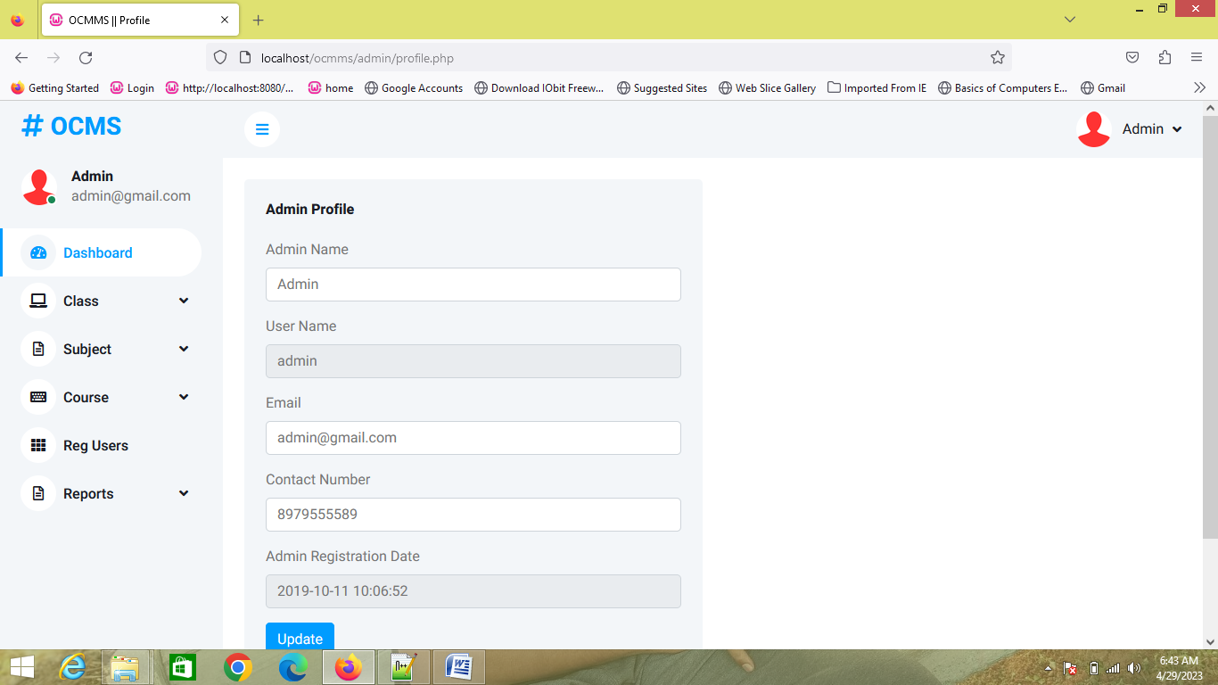

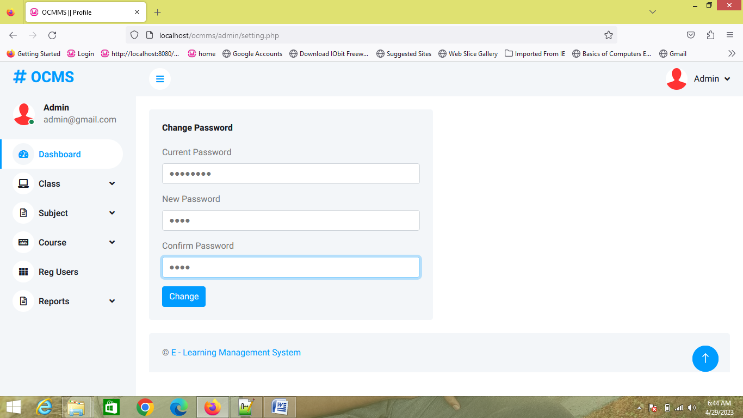

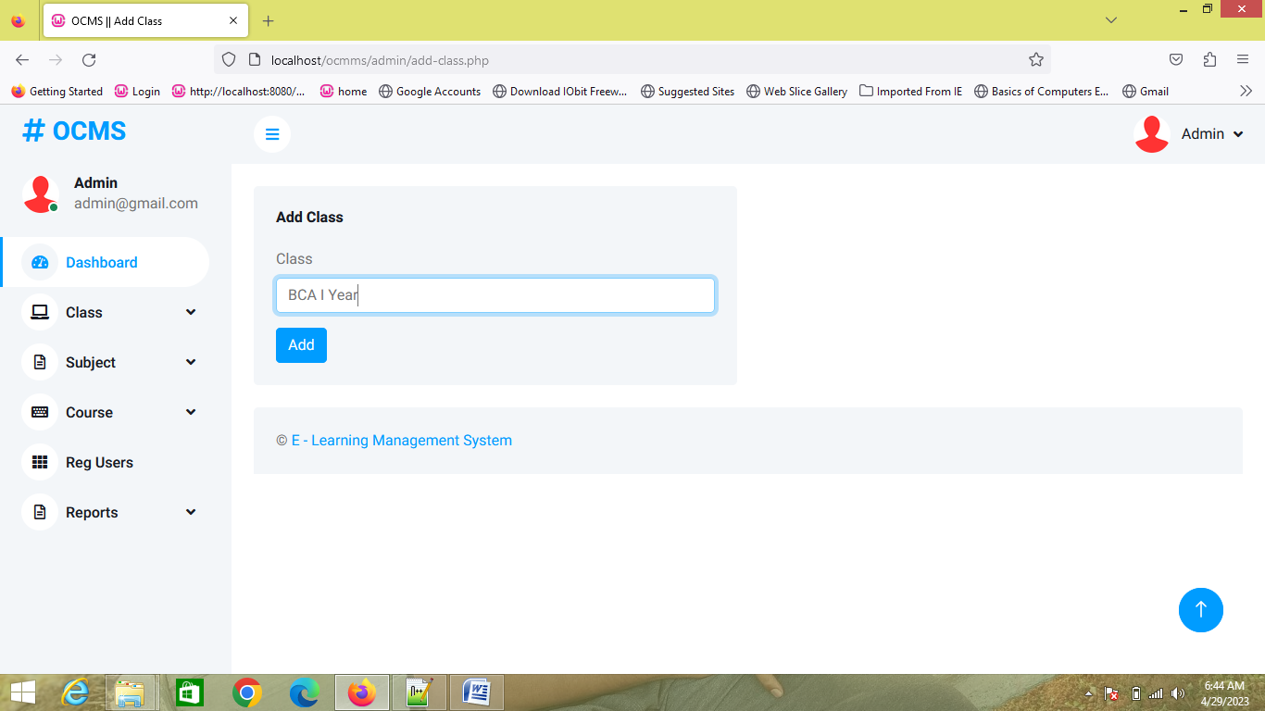

- OUTPUT:

